Spark Streaming:
Source : https://github.com/subhamkharwal
What:
- Processing data continuously when ever it arrives.
- Continuous input and continuous output.
How:
- External data: Kafka, socket, Incremental files, etc
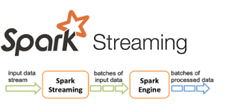
- Dived into small Micro-batches (D-stream)
- Processing each batch as RDD using Spark engine
- Transformation, cleaning etc
- Writing the result to sink.
- Maintaining Fault tolerance using Checkpoint
+ write a head log mechanisms.

Socket:
- Ubuntu
. sudo apt install ncat
. ncat -l <port>
. Ex: ncat -l 9999

